C string manipulation

## Program 1

**#include<stdio.h>  
void substr(char str[],char substring[],int start,int end){  
 int pos = 0;  
 while(start >= 0 && *(str+start) && start < end){  
 substring[pos] = *(str+start);  
 pos++;  
 start++;   
 }  
 substring[pos]='\0';  
   
}  
int main()  
{  
 char str[]="aadityaprabu\0";  
 char subst[10];  
 substr(str,subst,2,8);  
 printf("%s",subst);  
 substr(str,subst,0,8);  
 printf("\n%s",subst);  
 substr(str,subst,6,8);  
 printf("\n%s",subst);  
 return 0;  
}**

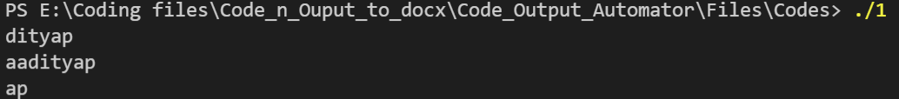

## Program 2

**#include<stdio.h>  
int main(){  
 char str[30];  
 int n;  
 printf("\nEnter a number length to extract:");  
 scanf("%d",&n);  
  
 printf("\nEnter a string:");  
 scanf("%s",str);  
   
 printf("\n%.*s",n,str);  
 return 0;  
}**

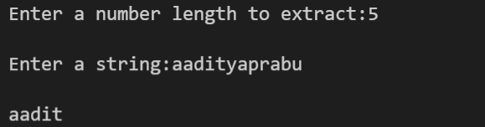

## Program 3

**#include<stdio.h>  
int isPallindrome(char str[],size_t n){  
 int p = 0;  
 n--;  
 int flag = 0;  
 while(p<n){  
 if(str[p]!=str[n]){  
 flag = 1;  
 }  
 p--;  
 n--;  
 }  
}  
int main(){  
 char str[100];  
 printf("Enter a string:");  
 scanf("%s",str);  
 int n =sizeof(str);  
 if(isPallindrome(str,n)){  
 printf("Pallindrome");  
 }  
 else{  
 printf("Not a Pallindrome");  
 }  
   
   
 return 0;  
}**



## Program 4

**#include<stdio.h>  
void substr(char str[],char substring[],int start,int end){  
 int pos = 0;  
 while(start >= 0 && *(str+start) && start < end){  
 substring[pos] = *(str+start);  
 pos++;  
 start++;   
 }  
 substring[pos]='\0';   
}  
int array_size(char str[]){  
 int len;  
 for(len =0 ;str[len];len++);  
 return len;  
}  
int isSubstr(char str[],char sub[]){  
   
 int s1 = array_size(str);  
 int s2 = array_size(sub);  
   
 for(int i=0;i<=s1-s2;i++){  
 int j;  
 for(j=0;j<s2;j++){  
 if(str[i+j] != sub[j]) break;  
 }  
 if(j == s2) return i;   
 }  
 return -1;  
}  
int deleteSubstr(char str[],char sub[]){  
 int pos = isSubstr(str,sub);  
 if(pos != -1){  
 int s1 =array_size(str);  
 int s2 = array_size(sub);  
 int idx = 0;  
 for(int i=0;i<pos;i++){  
 str[idx++] = str[i];  
 }  
 for(int i=pos+s2;i<s1;i++){  
 str[idx++] = str[i];  
 }  
 str[idx]='\0';  
 return 1;  
 }  
 return 0;  
}  
int main(){  
 char str[] = "aadityaprabu";  
 char sub[]= "yapra";  
  
 deleteSubstr(str,sub);  
 printf("%s",str);  
 return 0;  
}**



## Program 5

**#include<string.h>  
#include<stdio.h>  
  
int main(){  
 char listOfstrings[][20] = {"Ball", "Apple", "Cat"};  
 int n = sizeof(listOfstrings)/sizeof(listOfstrings[0]);  
 for(int i=0;i<n;i++){  
 printf("%s ",listOfstrings[i]);  
 }  
 printf("\n");  
 for(int i=0;i<n-1;i++){  
 char temp[20];  
 int pos;  
 strcpy(temp,listOfstrings[i]);  
 for(int j=i+1;j<n;j++){  
 if(strcmp(temp,listOfstrings[j])>0){  
 strcpy(temp,listOfstrings[j]);  
 pos = j;  
 }  
 }  
 strcpy(temp,listOfstrings[i]);  
 strcpy(listOfstrings[i],listOfstrings[pos]);  
 strcpy(listOfstrings[pos],temp);  
 }  
 for(int i=0;i<n;i++){  
 printf("%s ",listOfstrings[i]);  
 }  
 return 0;  
}**



## Program 6

**#include<stdio.h>  
  
size_t size(char str[]){  
 int len = 0;  
 for(len=0;str[len];len++);  
 return len;  
}  
int main(){  
 char str1[]="rtx";  
 char str2[]="gigabyte";  
 int n = size(str1);  
 int m = size(str2);  
 char str3[n+m];  
 int k = 0;  
 for(int i=0;str1[i];i++) {  
 str3[k++] = str1[i];  
 }  
 for(int i=0;str2[i];i++) {  
 str3[k++] = str2[i];  
 }  
 printf("%s",str3);  
  
 return 0;  
}**



## Program 7

**#include<stdio.h>  
int array_size(char str[]){  
 int len;  
 for(len =0 ;str[len];len++);  
 return len;  
}  
int substrFreq(char str[],char sub[]){  
 int count = 0;  
 int s1 = array_size(str);  
 int s2 = array_size(sub);  
   
 for(int i=0;i<=s1-s2;i++){  
 int j;  
 for(j=0;j<s2;j++){  
 if(str[i+j] != sub[j]) break;  
 }  
 if(j == s2) count++;   
 }  
 return count;  
}  
  
int main(){  
 char str[]="codeandcodeandcodeancode";  
 char sub[]="and";  
 printf("%d",substrFreq(str,sub));  
 return 0;  
}**



## Program 8

**#include <stdio.h>  
#include <string.h>  
#include<ctype.h>  
int main()  
{  
 char s[1000];   
 int i,vowels=0,consonants=0;  
   
 printf("Enter the string : ");  
 gets(s);  
   
 for(i=0;s[i];i++)   
 {  
 if(isalpha(s[i]))  
 {  
   
 if(s[i]=='a'|| s[i]=='e'||s[i]=='i'||s[i]=='o'||s[i]=='u'||s[i]=='A'||s[i]=='E'||s[i]=='I'||s[i]=='O' ||s[i]=='U')  
 vowels++;  
 else  
 consonants++;  
 }  
   
 }  
 printf("vowels = %d\n",vowels);  
 printf("consonants = %d\n",consonants);  
   
 return 0;  
}**



## Program 9

**#include<stdio.h>  
#include<string.h>  
int main(){  
 int n=10;  
 char abb[10][10];  
 for(int i=0;i<10;i++){  
 char name[100];  
 fgets(name,sizeof(name),stdin);  
 name[strcspn(name,"\n")] = '\0';  
 char space[] = " ";  
 char* token = strtok(name,space);  
 int j=0;  
 while(token!=NULL){  
 abb[i][j++] = token[0];  
 token = strtok(NULL,space);  
 }   
 abb[i][j]='\0';   
 printf("\n");  
 }  
 printf("[ ");  
 for(int i=0;i<10;i++){  
 printf("%s, ",abb[i]);  
 }  
 printf("]");  
 return 0;  
}**

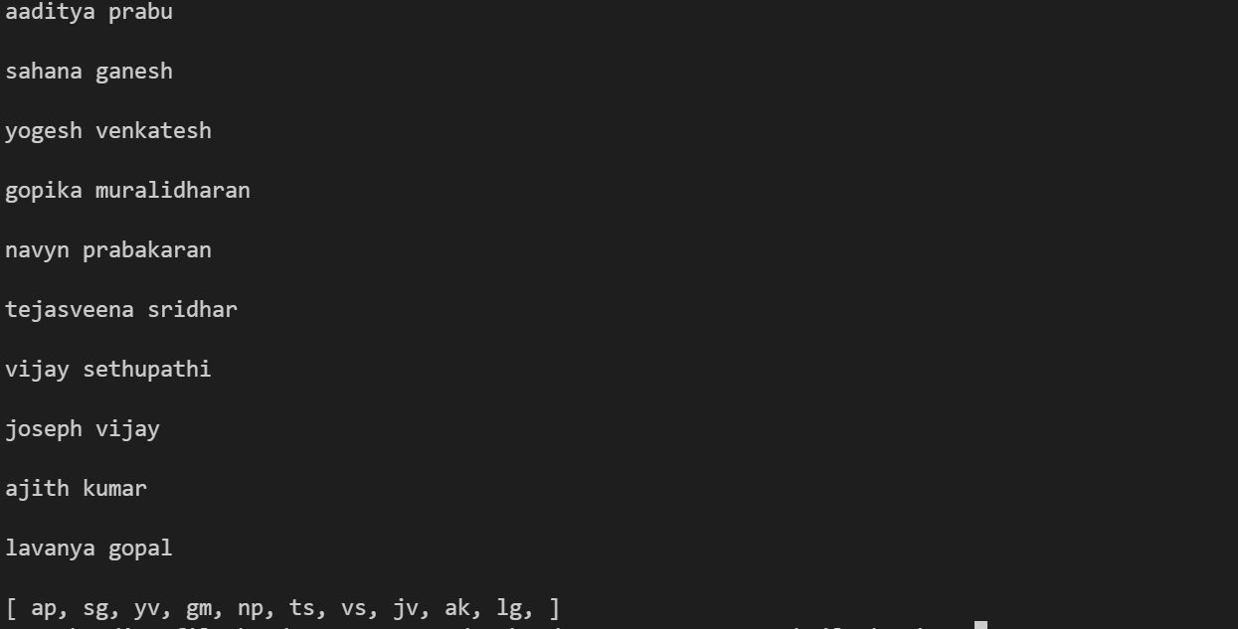

## Program 10

**#include<stdio.h>  
int main(){  
 int mat1[3][3]={  
 {1,2,3},  
 {4,5,6},  
 {7,8,9}  
 };  
 int mat2[3][3]={  
 {1,2,3},  
 {4,5,6},  
 {7,8,9}  
 };  
 int sum = 0;  
 for(int i=0;i<3;i++){  
 sum+=mat1[i][i];  
 sum+=mat1[i][3-1-i];  
 sum+=mat2[i][i];  
 sum+=mat2[i][3-1-i];  
 }  
 sum-= mat1[3/2][3/2];  
 sum-= mat2[3/2][3/2];  
  
 printf("Sum of two diags of two matrix is :%d",sum);  
 return 0;   
}**

